California Trip
12/29 Travel
12/30 BANDFEST - see all the bands in the parade perform in a field (preview / practice). Where? I don't know. Band kids have a warehouse float viewing, but I don't know if we can go.
12/31 Universal
1/1 Parade, and then a banquet in Huntington Beach
1/2 Disneyland - band performs in a parade, don't know what time, but it sounds like daytime / morning.
1/3 Airport - go home

------------------------------------------- Flight Information: (Confirmation # MV7W44) ---------------------------------------------------
Depart: 12/29/18 Flight 1280 DAL @ 1645 LAX @ 1810 Return: 1/3/19 Flight 430 LAX @ 1225 DAL @ 1720
---------------------------------- Rental Car information: (Hertz Confirmation # H78827365A3) ---------------------------------------
Pick up: 12/29/18 in LAX @ 1830 Hyundai Santa Fe Sport or similar (310) 568-5100 Return: 1/3/19 @ 1100
--------------------------- Hotel Information 12/29 - 01/01: (Ramada Confirmation # 802594897) ----------------------------------
Check in: 12/29/18 2156 E Colorado Blvd, Pasadena, CA 91107 (626) 788-0325 Check out: 01/01/19 (by noon)
---------- Hotel Information 01/01 - 01/03: (Quality Inn & Suites Anaheim Maingate Confirmstion # 41624364) -----------
Check in: 01/01/19 871 S Harbor Blvd, Anaheim, CA 92805 (714) 535-1331 Check out: 01/03/19 (by 11:00 am)
------------------------------------------------------------------- BANDFEST ---------------------------------------------------------------------------
Robinson Stadium, Pasadena City College 1570 E. Colorado Blvd. Tickets: $15.00ea thru: Sharp Seating
BANDFEST I BANDFEST II BANDFEST III
December 29, 2018 1:30 PM December 30, 2018 9:30 AM December 30, 2018 2:00 PM

----------------------------------------------------------- DECORATING PLACES ---------------------------------------------------------------------
Rosemont Pavilion: 700 Seco Street, Pasadena, CA 91103 Tickets: $15.00ea thru: Sharp Seating 626-795-4171 12/28: 11:00 am - 7:00 pm 12/29: 9:00 am - 7:00 pm 12/30: 11:00 am - 5:00 pm 12/31: 11:00 am - 1:00 pm
----------------------------------------------------------- UNIVERSAL STUDIOS ----------------------------------------------------------------------
100 Universal City Plaza, Universal City, CA 91608 Tickets: $124.00ea thru: Universal Studios 866-258-6546
-------------------------------------------------------------------- PARADE -------------------------------------------------------------------------------
The Parade starts at Orange Grove BLVD., goes down Colorado BLVD., and ends on Sierra Madre BLVD. FMHS- sec 1350
------------------------------------------------------------------- BANQUET -----------------------------------------------------------------------------
21500 Pacific Coast Hwy, Huntington Beach, CA 92648
------------------------------------------------------------------ Disneyland ----------------------------------------------------------------------------
1313 Disneyland Dr, Anaheim, CA 92802 Tickets: $135.00ea thru: Disneyland 714-781-4636

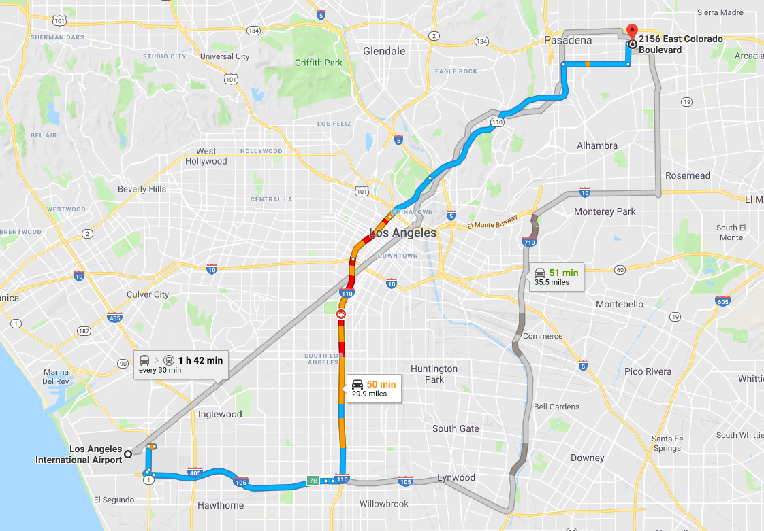
Below, stars mark the beginning and end, Diamonds mark the two hotels with availability, and the box marks Robinson Stadium. The blue line is the Parade route. FMHS 1350 marks the FM seating area.
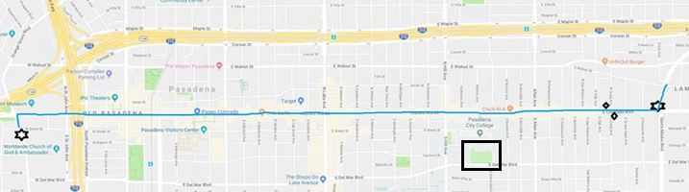
FMHS 1350
1350

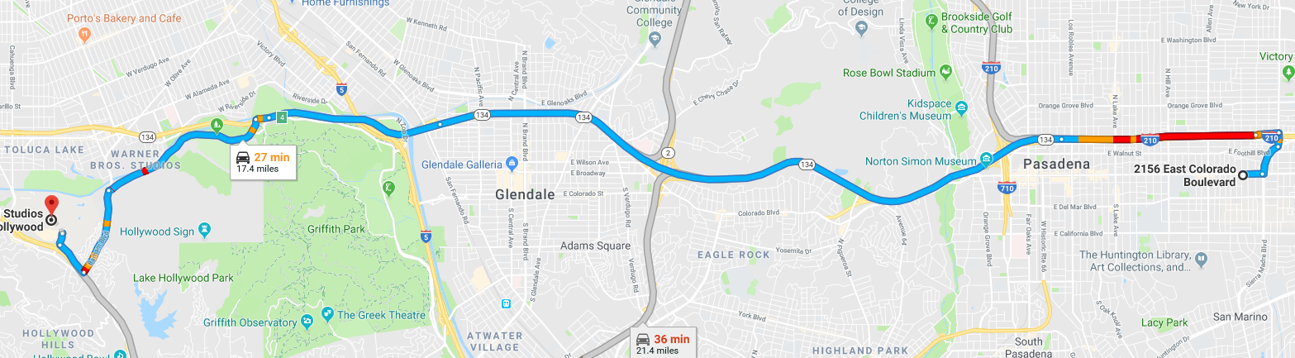

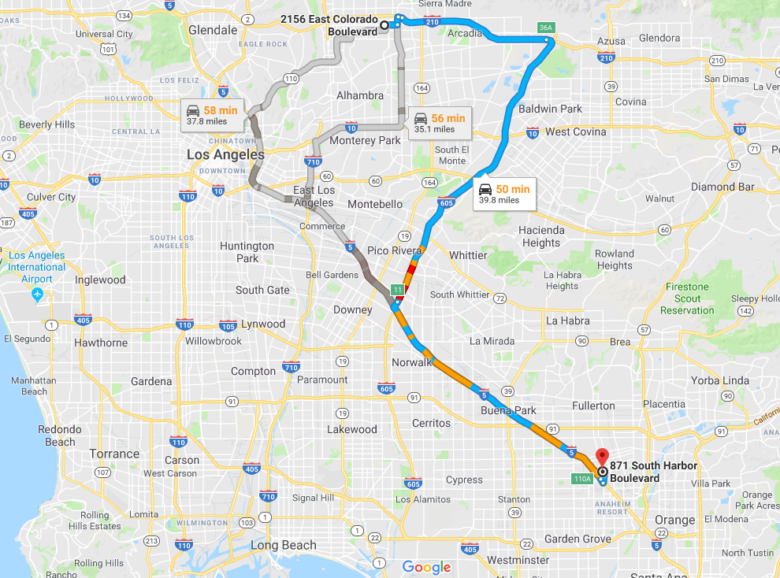

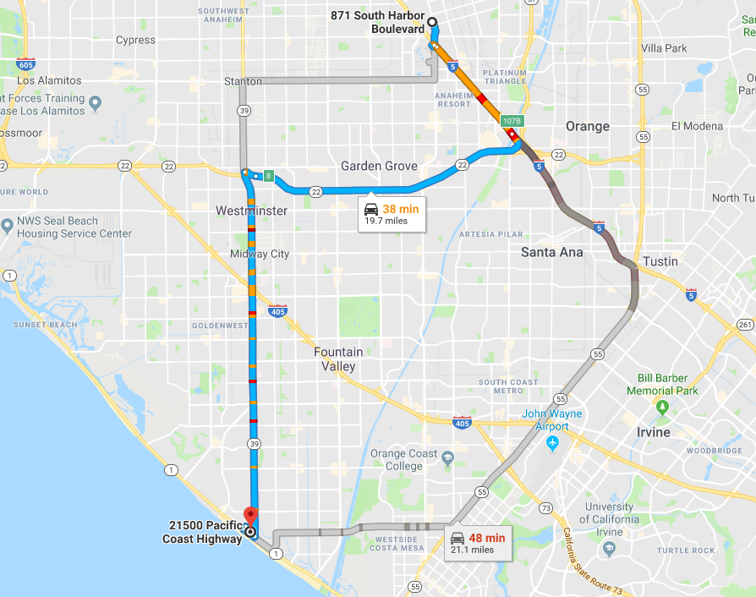

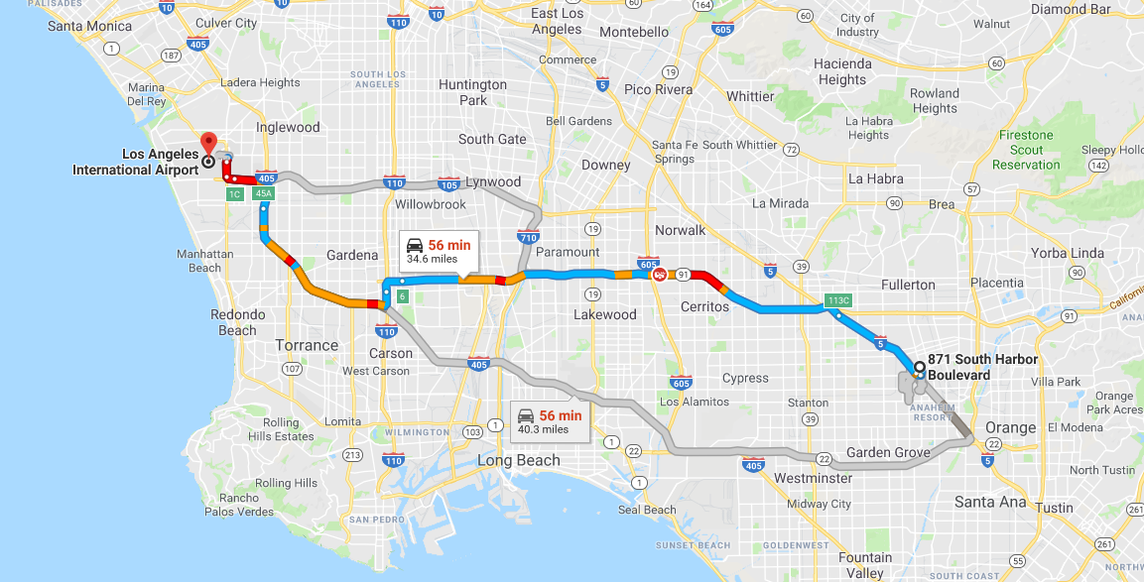
California Trip DETAILED INFO
------------------------------------------- Flight Information: (Confirmation # MV7W44) ---------------------------------------------------
Depart: 12/29/18 Flight 1280 DAL @ 1645 LAX @ 1810 Return: 1/3/19 Flight 430 LAX @ 1225 DAL @ 1720
Price Charged Early Bird Total Price Charged Early Bird Total
$279.00 $738.93 $60.00 $798.93 $236.00 $618.93 $60.00 $678.93
($222.00 new price $14.00 credit each)
Total Charged: $1,664.88 (to buy the needed points would have cost $2,007.50, not including Early Bird cost of $120.00)
---------------------------------- Rental Car information: (Hertz Confirmation # H78827365A3) ---------------------------------------
Pick up rental car in LAX @ 1830 on 12/29/18 Return @ 1100 on 1/3/19
Company Vehicle Price at counter Online Price SWA at counter
www.advantage.com Hyundai Santa Fe or Similar $586.29 $570.75
www.alamo.com Hyundai Santa Fe or Similar $744.34
www.avis.com Ford Escape or similar $1000.00 $850.00 $850.00 (A39480)
www.budget.com Ford Escape or similar $1000.00 $850.00 $858.00 (T50440)

www.dollar.com Jeep Compass or Similar $750.00 $680.07 $489.00 (WN213)

Hyundai Santa Fe or Similar $1003.00 $907.79 $627.15 (WN213)
www.enterprise.com Hyundai Santa Fe or similar $727.51
Toyota RAV4 or similar $534.38
www.foxrentacar.com Jeep Compass or Similar $781.65 $671.08
Jeep Grand Cherokee or Similar $1017.47 $871.53
www.hertz.com Hyundai Santa Fe Sport or similar $1452.65 $1241.87 $518.61 (1858645)
www.nationalcar.com Hyundai Santa Fe or similar $738.06
www.paylesscar.com sold out
www.sixt.com Kia Sportage or similar $378.63 / $517.19 $310.71(+ other fees)
Toyota 4Runner or similar $435.12 / $587.89 $357.11(+ other fees)
www.thrifty.com Jeep Compass (or similar) $810.89 $734.33 $696.07 (WN213)
--------------------------- Hotel Information 12/29 - 01/01: (Ramada Confirmation # 802594897) ----------------------------------
2156 E Colorado Blvd, Pasadena, CA 91107 (626) 788-0325 Aaron or Angela ( Street view )
Check in: on 12/29/18 Check out: 01/01/19 2 queens Balcony room $750 per night + tax = total $2,587.53
Check out is 11:00am with a 1 hour grace period, so out by 12:00 noon.
---------- Hotel Information 01/01 - 01/03: (Quality Inn & Suites Anaheim Maingate Confirmstion # 41624364) -----------
871 S Harbor Blvd, Anaheim, CA 92805 (714) 535-1331
Check in: on 01/01/19 Check out: 01/03/19 2 queens & sofa bed $114.75 per night + tax = estimated total $283.93
Check out is 11:00am
------------------------------------------------------------------- BANDFEST ---------------------------------------------------------------------------
presented by REMO will feature the outstanding bands selected to participate in the 2019 Rose Parade. Over the course of two days, each band, along with its auxiliary performers, will present the field show that has led to its success.
Three Bandfest events will take place at Robinson Stadium, Pasadena City College (1570 E. Colorado Blvd). Free parking in Structure 4 off Del Mar Ave.
Advance tickets are available through Sharp Seating Company for $15 (children 5 and under are free). Tickets may also be purchased at the venue beginning 30 minutes prior to the performance time, pending availability.
BANDFEST I BANDFEST II BANDFEST III
December 29, 2018 1:30 PM December 30, 2018 9:30 AM December 30, 2018 2:00 PM

----------------------------------------------------------- DECORATING PLACES ---------------------------------------------------------------------

Rosemont Pavilion: 700 Seco Street, Pasadena, CA 91103 Tickets: $15.00ea thru: Sharp Seating 626-795-4171 12/28: 11:00 am - 7:00 pm 12/29: 9:00 am - 7:00 pm 12/30: 11:00 am - 5:00 pm 12/31: 11:00 am - 1:00 pm
----------------------------------------------------------- UNIVERSAL STUDIOS ----------------------------------------------------------------------
100 Universal City Plaza, Universal City, CA 91608 Tickets: $124.00ea thru: Universal Studios 866-258-6546

-------------------------------------------------------------------- PARADE -------------------------------------------------------------------------------
The Parade starts at Orange Grove BLVD., goes down Colorado BLVD., and ends on Sierra Madre BLVD. FMHS- sec 1350
Q. How early should I be in my seat?
A. The parade begins promptly at 8:00 am. It is recommended you are seated by 7:00 a.m. if seated at the start of the parade west of Fair Oaks Ave. Otherwise we recommend being seated by 8:00 a.m. Regardless of where you are seated you should plan to arrive in the area at least two hours prior.
Q. Are the seats reserved?
A. Yes, all seats are reserved and numbered. We have ushers at each grandstand to help guide you to your assigned seat.
Q. When should I arrive at my parking lot?
A. You should plan to arrive 2 hours prior to the estimated time of arrival of the parade for your seating area. For example, if you are sitting at the beginning of the parade route you should park by 6:00 a.m. If you are sitting at mid parade you should park by 7:00 a.m.
------------------------------------------------------------------- BANQUET -----------------------------------------------------------------------------
21500 Pacific Coast Hwy, Huntington Beach, CA 92648
------------------------------------------------------------------ Disneyland ----------------------------------------------------------------------------
1313 Disneyland Dr, Anaheim, CA 92802 Tickets: $135.00ea thru: Disneyland 714-781-4636
------------------------------------------------------------------------ Links -------------------------------------------------------------------------------
https://www.visitpasadena.com/ (626) 795-9311
https://ww5.cityofpasadena.net/main/ (626) 744-7311
https://tournamentofroses.com/ (626) 449-4100
http://www.sharpseating.com/Rose-Parade-Festivities.php (626)795-4171
https://www.musictravel.com/ (317) 637-0837

